3w

 

Q1:

Software Requirements Specification

for

**Koi Order System**

**Version 1.0 approved**

**Prepared by**

**FB: Chí Cường**

**<organization>[Student must replace this line by the name of the FU Campus you take the exam] (0.1 point)**

**<date created> [Student must replace this line by the date you take the exam] (0.1 point)**

Q2:

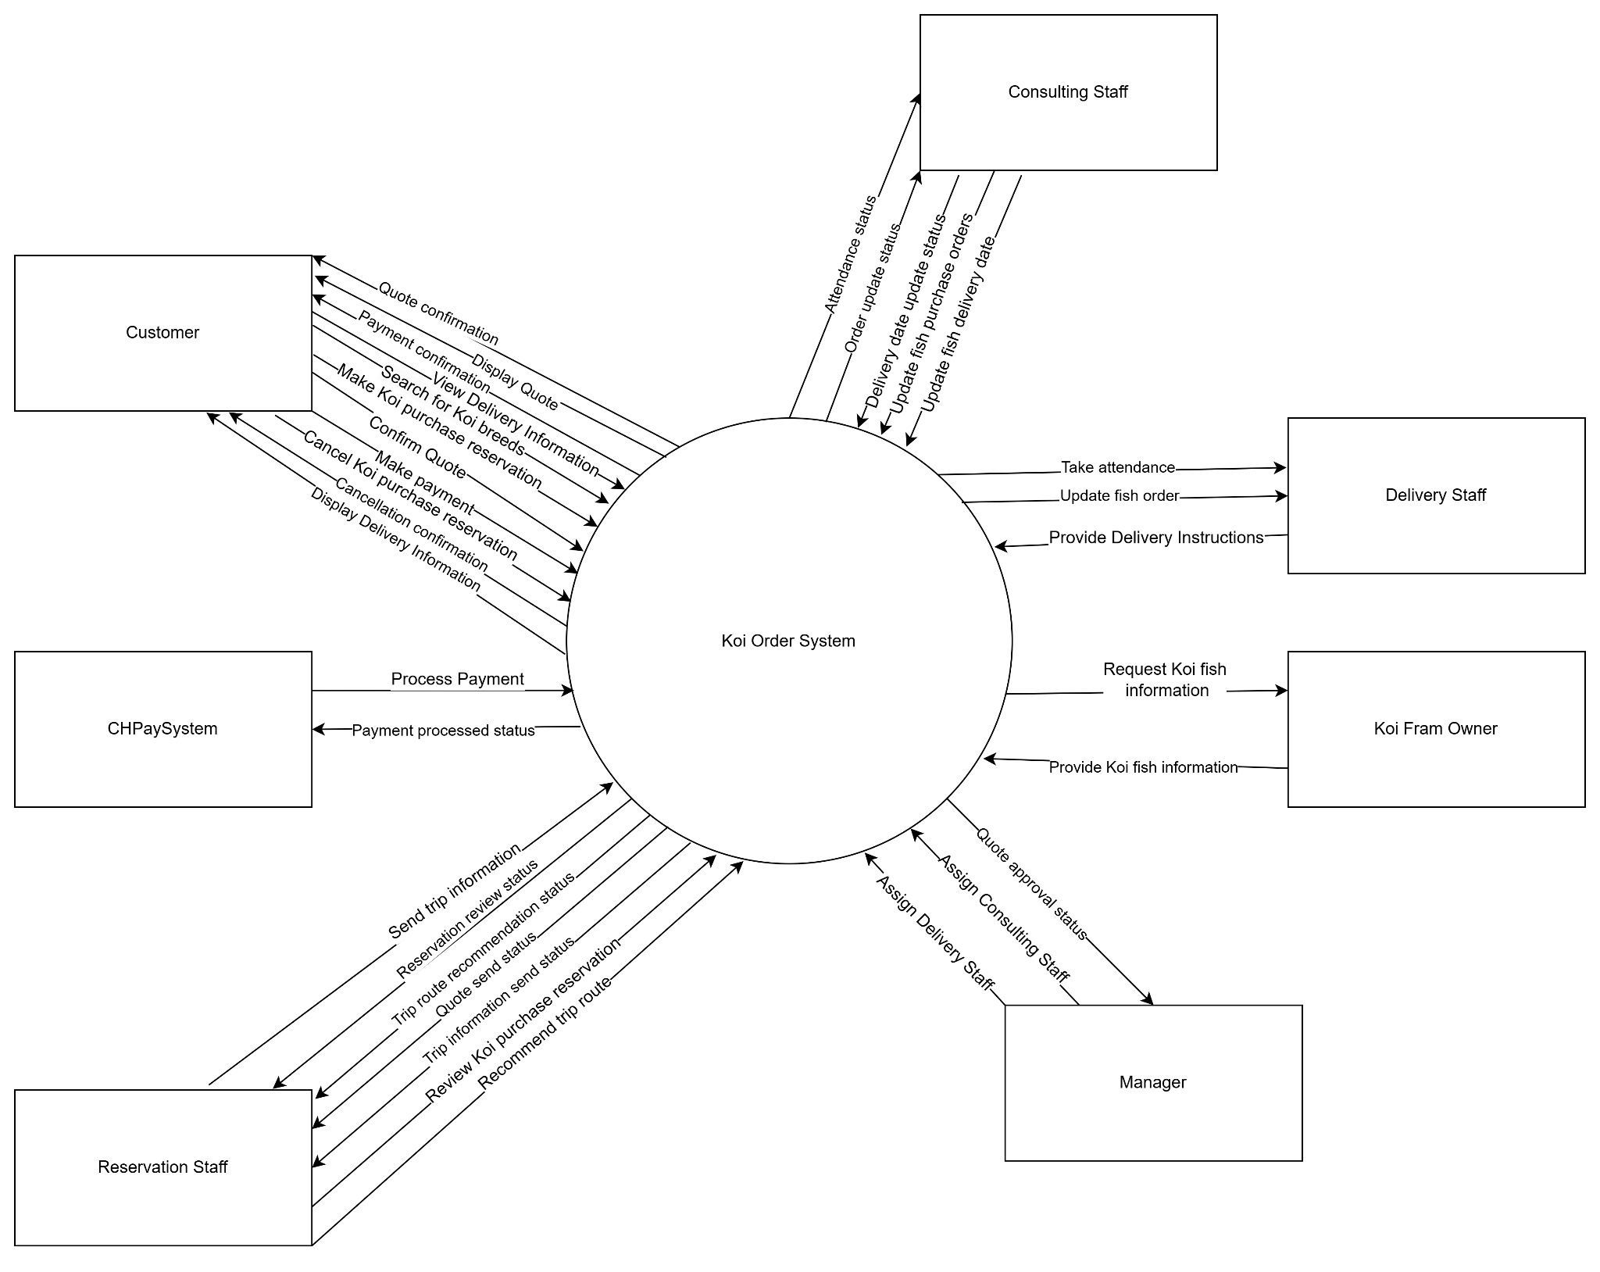

Q3:

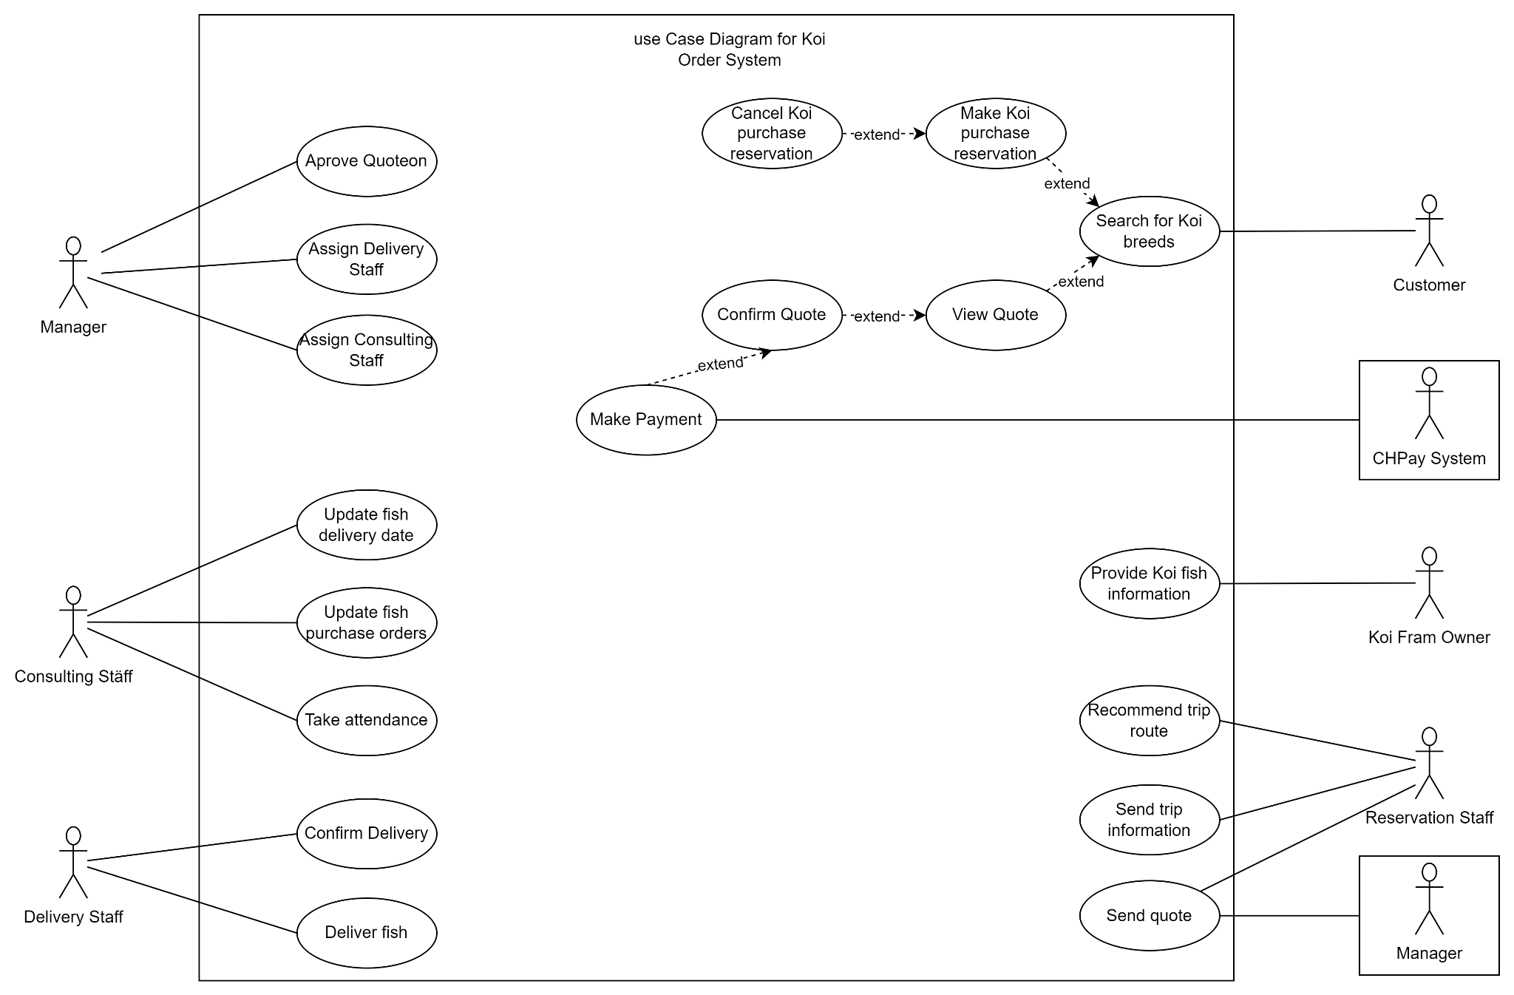

|  |  |  |
| --- | --- | --- |
| **#** | **Actor** | **Description** |
| 01 | Customer | The user interacts with the system to search for Koi fish breeds, make reservations to purchase Koi fish, confirm quotes, make payments, and manage their Koi fish orders. Customers can also cancel reservations before 48 hours of the trip departure date and top up their wallet in the system to place orders. |
| 02 | Reservation Staff | The staff responsible for reviewing customer reservation requests, recommending trip routes, sending quotes to customers, and providing trip details (airfare, hotel, etc.) after the customer has made the payment. |
| 03 | Consulting Staff | The staff responsible for managing and updating information during the trip to visit Koi farms, including taking attendance at the airport on the departure date, updating the customer's fish purchase orders after negotiating prices with the farm owner, and updating the fish delivery date after the trip. |
| 04 | Manager | The staff responsible for delivering Koi fish to customers and confirming the delivery after receiving the remaining payment from the customer. |
| 05 | CHPay System | The payment processing system that handles customer transactions for Koi fish reservations. The CHPay System ensures that payments are completed before the reservation is accepted. |
| 06 | Koi Farm Owner | The farm owner provides information about Koi fish, including breeds, reference selling prices based on breed, size, and age, and assists in negotiating the purchase price with consulting staff during the farm visit. |

|  |  |  |  |
| --- | --- | --- | --- |
| **#** | **Use Case** | **Actors** | **Description** |
| UC-01 | Search for Koi breeds | Customer | The customer searches for information on different Koi fish breeds (e.g., Kohaku, Showa, Ogon) raised by various Koi farms in Japan. The system provides reference selling prices based on breed, size, and age. |
| UC-02 | Make Koi purchase reservation | Customer | The customer makes a reservation to purchase Koi fish from Japanese farms, specifying their desired breeds, farm, expected departure date, and total expected budget. Reservation staff reviews the request. |
| UC-03 | Review Koi purchase reservation | Reservation Staff | The reservation staff reviews the Koi purchase reservation made by the customer and recommends a suitable trip route through the farms, along with the associated costs. |
| UC-04 | Send Quote | Reservation Staff | The reservation staff sends the quote to the customer after it has been approved by the manager. The quote includes trip details and costs. |
| UC-05 | Approve Quote | Manager | The manager reviews and approves the quote before it is sent to the customer. The quote must be approved for the customer to view it. |
| UC-06 | Confirm Quote | Customer | The customer confirms the quote and agrees to the terms, initiating the payment process through the CHPay system. |
| UC-07 | Make Payment | Customer | The customer makes the required payment for the reservation through the CHPay online payment system. The reservation is only accepted after payment is confirmed. |
| UC-08 | Send Trip Information | Reservation Staff | After payment is completed, the reservation staff sends specific trip information (airfare, hotel, etc.) to the customer. |
| UC-09 | Cancel Koi purchase reservation | Customer | The customer can cancel the Koi purchase reservation before 48 hours of the trip departure date, but they must pay the airfare and hotel fees. |
| UC-10 | Assign Consulting Staff | Manager | The manager assigns consulting staff to handle the Koi purchase reservation. Consulting staff can only view reservations assigned to them. |
| UC-11 | Take Attendance | Consulting Staff | On the departure date, the consulting staff takes attendance of the customers at the airport to ensure all participants are present. |
| UC-12 | Update Fish Purchase Orders | Consulting Staff | During the trip, the consulting staff updates the system with the customer's fish purchase orders after negotiating the final price with the farm owner. |
| UC-12 | Update Fish Delivery Date | Consulting Staff | At the end of the trip, the consulting staff updates the fish delivery date in the system. |
| UC-13 | View Delivery Information | Customer | The customer can view detailed information about the fish delivery date through the system. |
| UC-14 | Deliver Fish | Delivery Staff | The delivery staff delivers the fish to the customer and ensures the customer receives them in good condition. |
| UC-15 | Confirm Delivery | Delivery Staff | The delivery staff confirms the delivery in the system after receiving the remaining payment from the customer. |
| UC-16 | Provide Koi Fish Information | Koi Farm Owner | The Koi farm owner provides detailed information about the Koi fish, including breeds, prices, and availability, to be used by the system for customer searches and reservations. |

Q4:

|  |  |  |
| --- | --- | --- |
| **ID** | **Rule Definition** | **Use cases** |
| BR-01 | A manager must approve the quote before it can be sent to the customer. | UC-05 |
| BR-02 | Customers must make the required payment through the CHPay system before the Koi purchase reservation is accepted. | UC-07 |
| BR-03 | Customers can cancel the Koi purchase reservation up to 48 hours before the trip departure date, but they will be charged for airfare and hotel fees. | UC-09 |
| BR-04 | Customers must deposit 30% of the value of the fish to place a fish order. This amount is deducted from the customer’s wallet in the system. | UC-07 |

**Q5:**

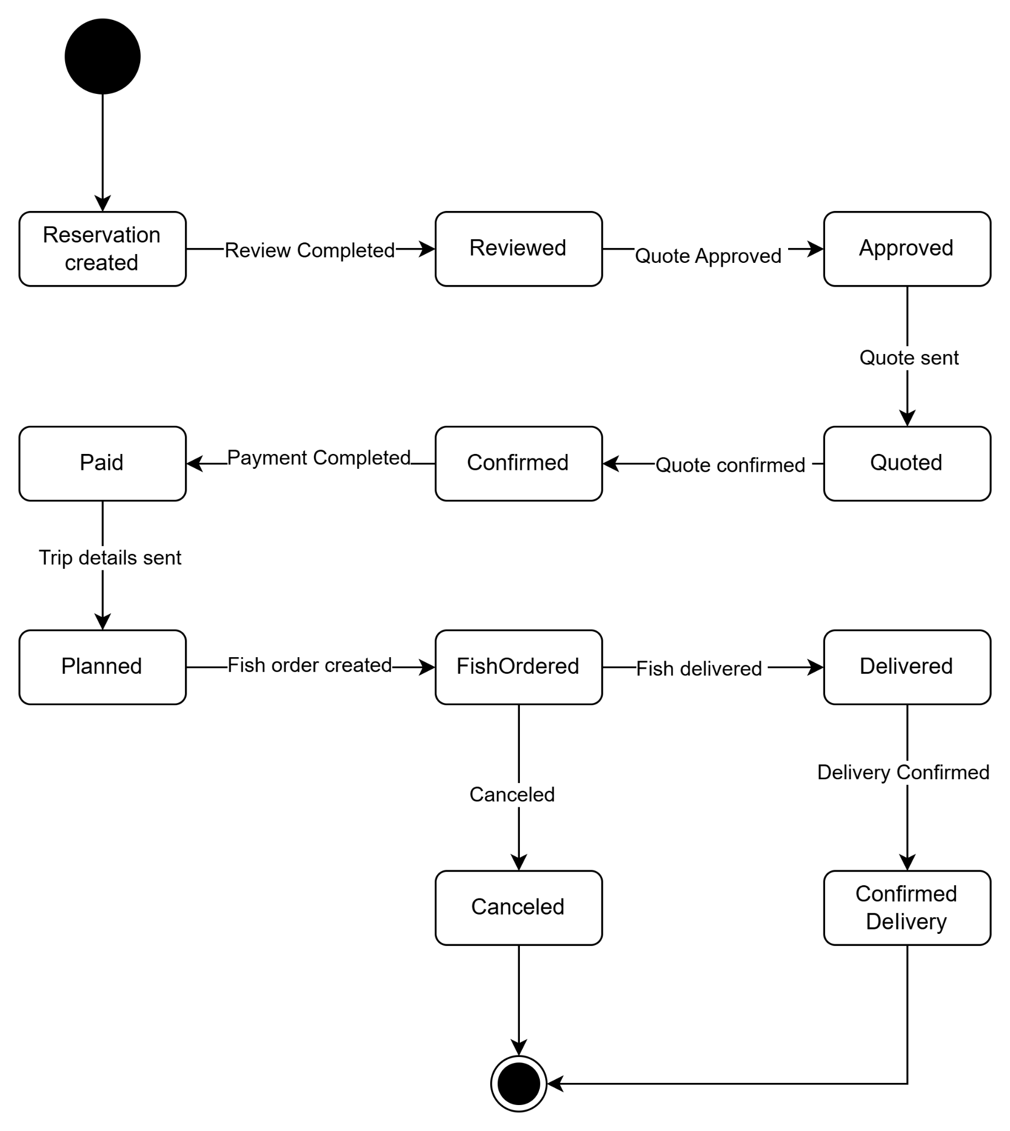

|  |  |  |
| --- | --- | --- |
| **#** | **State** | **Description** |
| 01 | Reservation created | The state when a reservation request is created. |
| 02 | Reviewed | The state when the reservation request has been reviewed by the staff. |
| 03 | Quoted | The state when the quote has been sent to the customer. |
| 04 | Approved | The state when the quote has been approved by the manager. |
| 05 | Confirmed | The state when the customer confirms the quote. |
| 06 | Paid | The state when the customer completes the payment. |
| 07 | Planned | The state when the trip details have been sent to the customer. |
| 08 | Fish Ordered | The state when the fish purchase order is created. |
| 09 | Delivered | The state when the delivery staff confirms the delivery. |
| 10 | Confirmed Delivery | The state when the delivery staff confirms the delivery. |
| 11 | Canceled | The state when the customer cancels the reservation before 48 hours. |